Azure Cloud

**Aim**: - Create a Windows Server 2019 virtual machine, IIS and reset vm password in the Azure portal.

# **Create a Windows Server 2019 virtual machine in the Azure portal**

Azure virtual machines (VMs) can be created through the Azure portal. This method provides a browser-based user interface to create VMs and their associated resources. To shows you how to use the Azure portal to deploy a virtual machine (VM) in Azure that runs Windows Server 2019. To see your VM in action, you then RDP to the VM and install the IIS web server.

1. Sign in to Azure

2. [Create virtual machine](https://learn.microsoft.com/en-us/azure/virtual-machines/linux/quick-create-portal?tabs=ubuntu#create-virtual-machine)

3. [Connect to virtual machine](https://learn.microsoft.com/en-us/azure/virtual-machines/linux/quick-create-portal?tabs=ubuntu#connect-to-virtual-machine)

4. [Install web server](https://learn.microsoft.com/en-us/azure/virtual-machines/linux/quick-create-portal?tabs=ubuntu#install-web-server) (IIS)

5. View the IIS welcome page

6. Reset Azure VM password

7. [Clean up resources](https://learn.microsoft.com/en-us/azure/virtual-machines/linux/quick-create-portal?tabs=ubuntu#clean-up-resources)

1. Sign in to Azure

Sign in to the Azure Portal and go to the Azure portal home page <https://portal.azure.com/#home>.

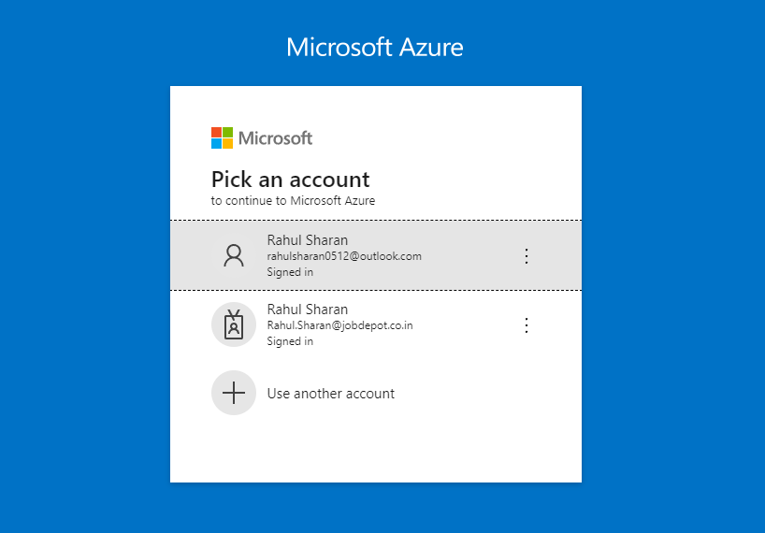

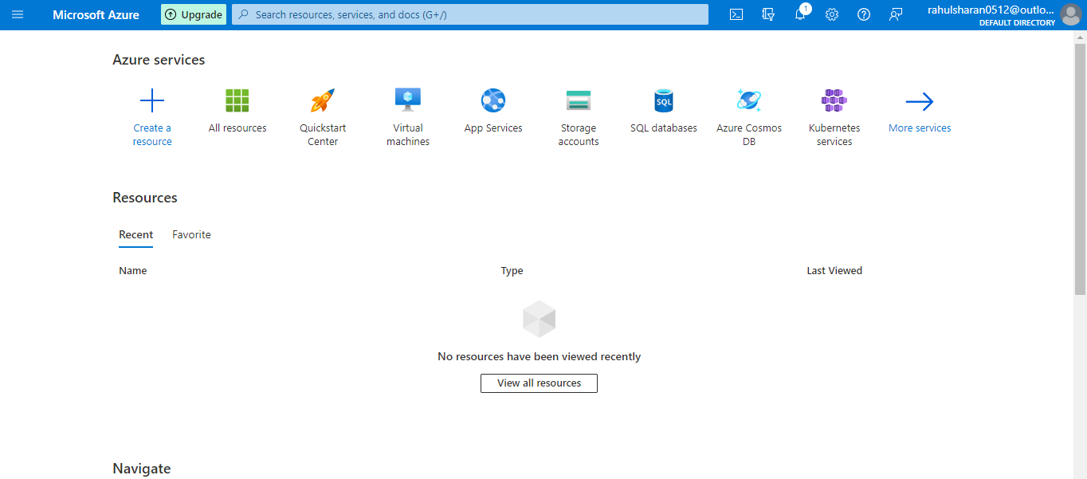

2. Create virtual machine

1. Enter virtual machines in the search.

2. Under **Services**, select **Virtual machines.**

3. In the Virtual machines page, select Create and then Virtual machine. The Create a virtualmachine page opens.

4. In the Basics tab, under Project details, Select the free trial subscription and then choose to create new resource group. Enter jobdepot for the name.

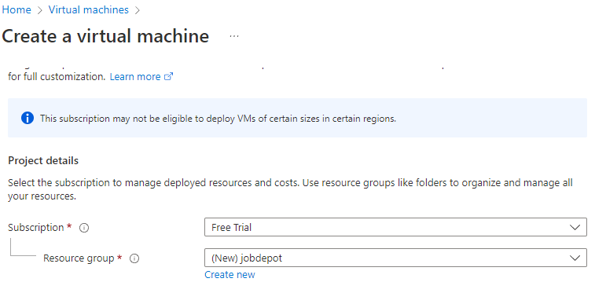

5. Under Instance details, enter myvm for the Virtual machine name, and choose Windows Server 19 Datacentre- Gen2 for your Image. Leave the other defaults. Size availability and pricing are dependent on your region and subscription.

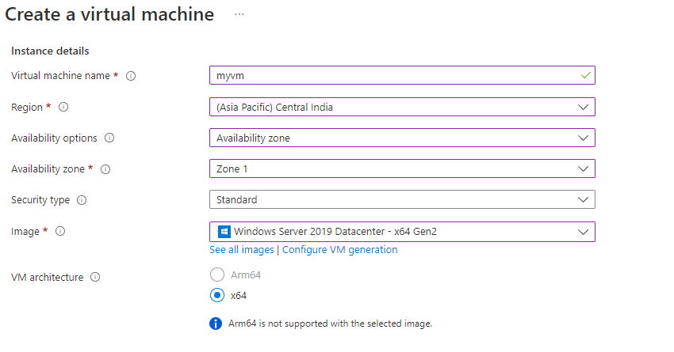

6. The default size and pricing is only shown as an example Standard B1s-1GiB Memory.

7. Under Administrator account, provide a username, such as admin01 and a password. The password must be at least 12 characters long and meet the [defined complexity requirements](https://learn.microsoft.com/en-us/azure/virtual-machines/windows/faq#what-are-the-password-requirements-when-creating-a-vm-).

8. Under Inbound port rules, choose Allow selected ports and then select RDP (3389) and HTTP (80) from the drop-down.

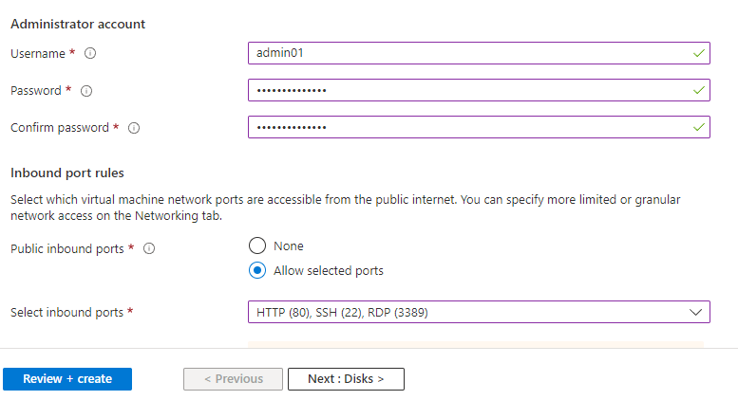

9. Leave the remaining defaults and then select the Review + create button at the bottom of the page.

10. On the Create a virtual machine page, you can see the details about the VM you are about to create. When you are ready, select Create.

11. When the deployment is finished, select go to resource.

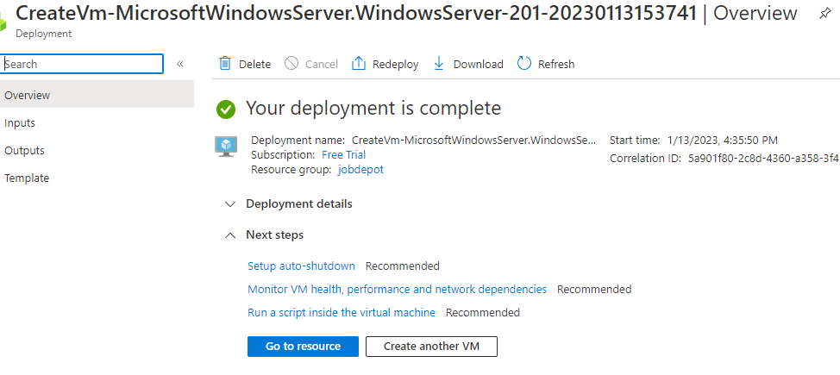

3. Connect to virtual machine

Create a remote desktop connection to the virtual machine. These directions tell you how to connect to your VM from a Windows computer.

1. On the overview page for your virtual machine, select the Connect > RDP.

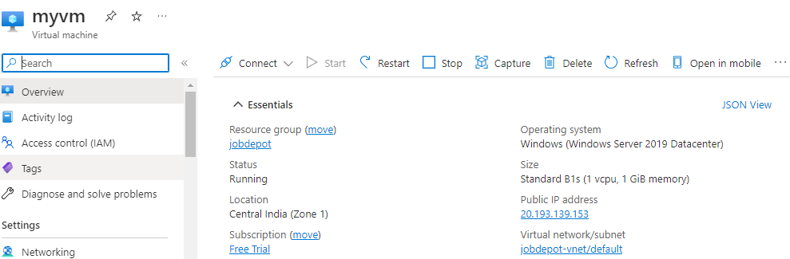

1. In the Connect with RDP tab, keep the default options to connect by IP address, over port 3389, and click Download RDP file.

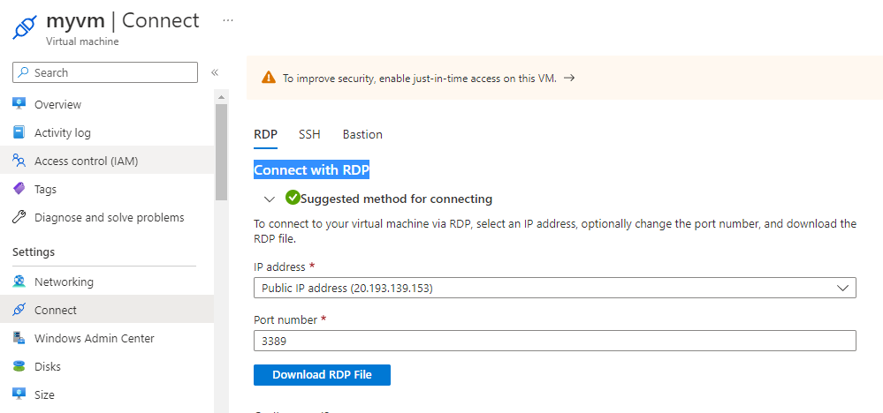

1. Open the downloaded RDP file and click Connect when prompted.
2. In the Windows Security window, select more choices and then Use a different account. Type the username as localhost\username, enter the password you created for the virtual machine, and then click OK.
3. You may receive a certificate warning during the sign-in process. Click yes or continue to create the connection.

4. Install web server (IIS)

To add web server role on virtual machine, and then you will be able to access your virtual machine IIS default page. After, that just add website on IIS and browse it.

1. Open Server Manager-Dashboard & click on Add roles and features.

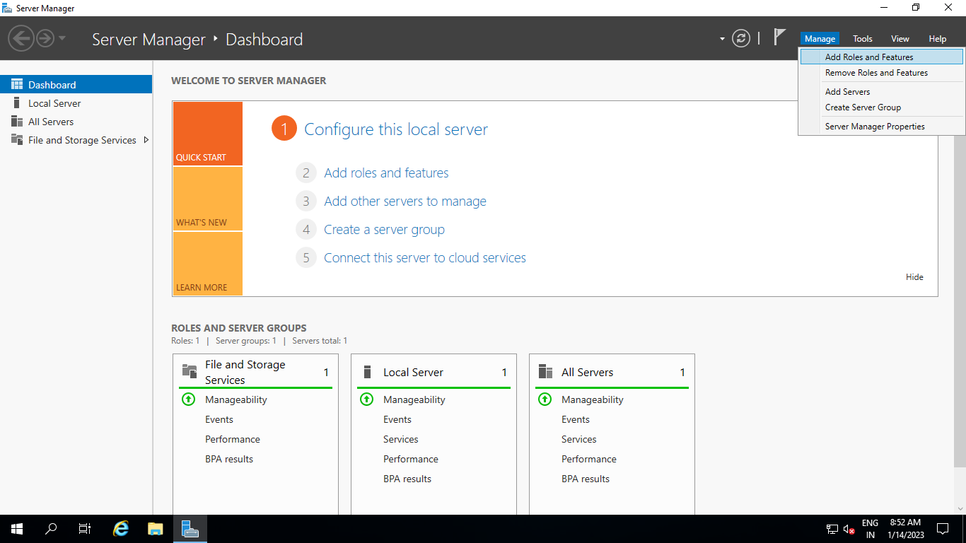

1. Click Next Keep default selection for Installation Type & Server selection.

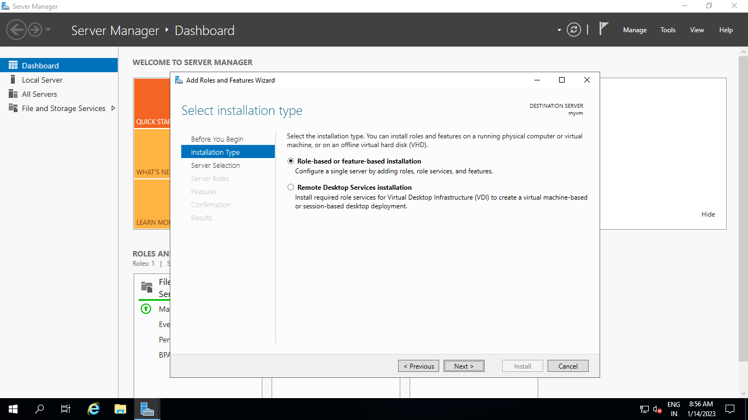

1. Select Server Roles as Web Server (IIS) & Add features.

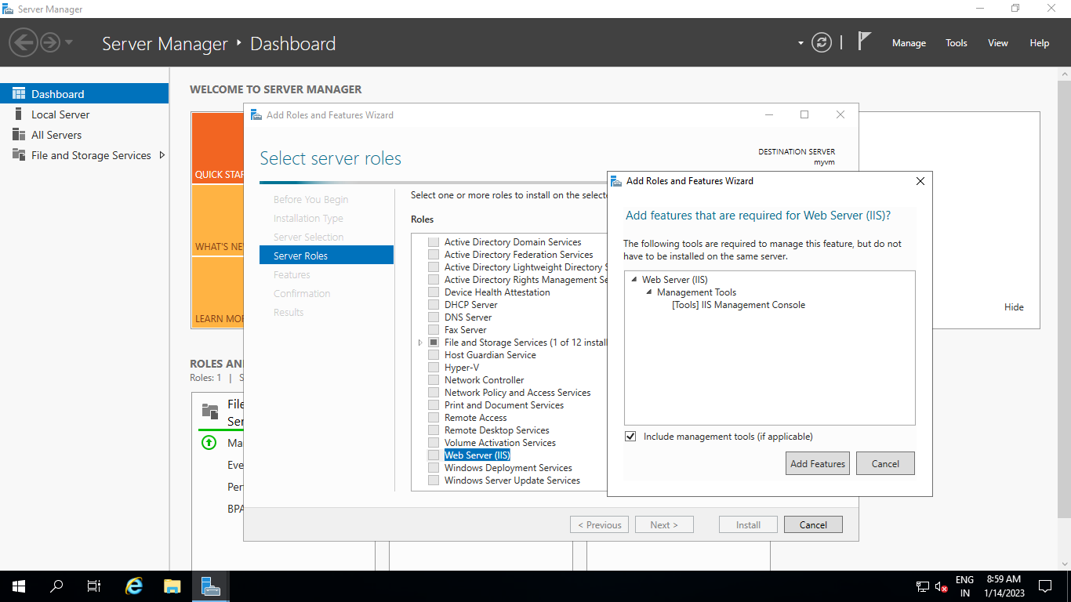

1. Again, keep default selection and Click-Install.

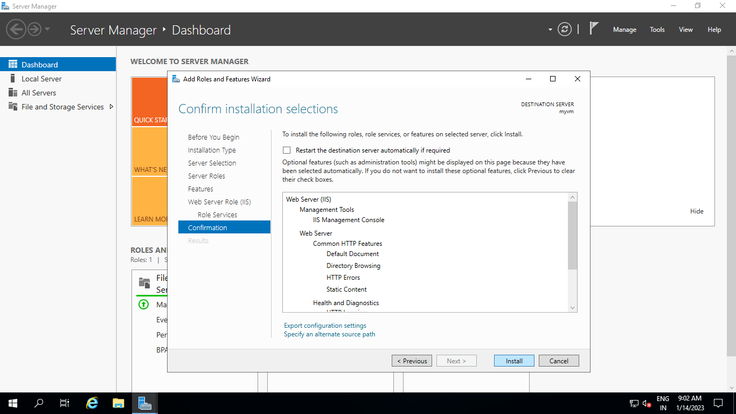

5. View the IIS welcome page

Once completed, go-to Virtual Machine and copy Public IP-address & browse it. We will be able to get access IIS.

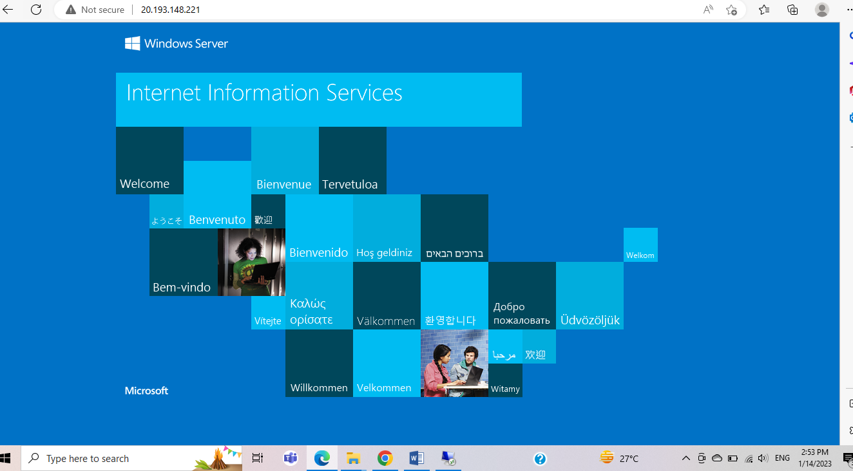

1. Reset Azure VM password
2. From the left side menu select Reset password option under help.
3. Now if you will click on the Reset password option again. You can able to see the Reset Password option is enabled. Choose the Mode as Reset password.
4. Enter the username, Password and confirm password and then click on the Update button.

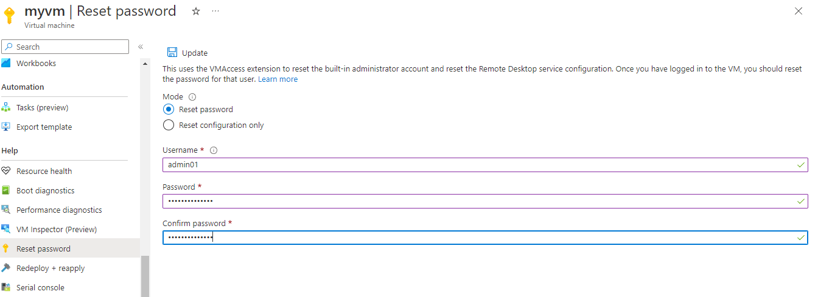

1. Clean up resources
2. When no longer needed, you can delete the resource group, virtual machine, and all related resources.
3. On the Overview page for the VM, select the Resource group link.
4. At the top of the page for the resource group, select Delete resource group.
5. A page will open warning you that you are about to delete resources. Type the name of the resource group and select Delete to finish deleting the resources and the resource group.

